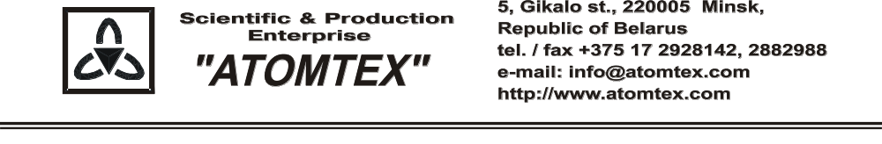

CALIBRATION CERTIFICATE

Date of calibration 13.02.2019.

Type Radiation monitor AT6130A

S/N 15275

Measurement limits:
from 0.1 μSv/h to 10,0 mSv/h.

Measurement error ± 20 %

Operating conditions:

Air temperature +19°C
Atmospheric pressure 96,8 kPa
Relative humidity 75%

The instrument is calibrated on the standard dosimetry facility AT-130, N 015, error ±4% (the Certificate of Compliance N 210/1427-2018 on 23.10.2018 issued by FGUP "D.I.Mendeleyev VNIIM", St. Petersburg, Russia); AT-110, N 013, error ±5% (the Certificate of Compliance N 210/1426-2018 on 22.10.2018 issued by FGUP "D.I.Mendeleyev VNIIM", St. Petersburg, Russia).

Calibration data

Gamma radiation

Conventionally true value (CTV) of dose rate, 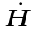*o_{i}(10) | Calibration data
0.70 µSv/h | 0.69 µSv/h
7.0 µSv/h | 7.0 µSv/h
70.0 µSv/h | 71.0 µSv/h
0.70 mSv/h | 0.66 mSv/h
7.0 mSv/h | 7.0 mSv/h

Calibrated by: S. Kulchynski _____________
(signature)

Technical control: N. Kurbatova _____________
(signature)

